Introduction

SingapuraAir is a global company providing the highest quality in terms of air transportation. Founded in 2012, SingapuraAir flies one of the youngest aircraft fleets in the world to destinations spanning a network spread over six continents. Today, we internationally recognized as the world's leading airline and operate a modern passenger fleet of more than 20 aircraft.

Products & Services

Your role will be to deliver and support a consistently high standard of customer service across the entire Singapura Air network. Equally important is the development of new products and services to maintain Singapura Airs’ leadership in the industry through differentiation and innovation.

Departments and Staffs

**IT Department**

Manager: Joeven Valenzuela

Supervisor: MaimaiMansanades

Team Members: Angel Locsin, Christine Reyes

**Human Resource Department**

Manager: Jason Albores

Supervisor: Isaiah San Jose

Team members: Danica Torres, Cyril Locsin

**Marketing Department**

Manager: Ron Derek De Ramos

Supervisor: Perigrine Rivera

Team members: SolennHuesaff, Isabelle Daza

**Accounting Department**

Manager: Kenneth Manansala

Supervisor: Kalvin James Manansala

Team members: Gerryl Sierra, John Michael Mendez

**Customer Service Department**

Manager: Joey Reyes

Supervisor: ChelaiManansala

Team member: Camille Rivera, Sarah Jean Valenzuela

**Pilots, Flight Attendants and Crews**

Capt. Juan Dela Cruz

Capt. Juan Dela Cruz II

Capt. Juan Dela Cruz III

Paulene So

Akira Hassan

PalomaEsmeria

Achievements

Best Airlines in South East Asia 2012

Airline of the Year 2012 (2nd Consecutive Years)

Most Trusted Airline 2013

Objectives

* To provide excellent services between our shareholders and customers.
* To be able to install Linux Operating System to Singapura Air company.
* To be able to create users and groups for each departments and administrators.
* To be able to show common Linux command that we commonly use.

System Requirements

Intel or AMD x86 processor

RAM size: 2GB to 4GB

Hard Drive Size: 500GB to 2TB

Processor Speed: 1.7GHz

Display: 1200 x 800

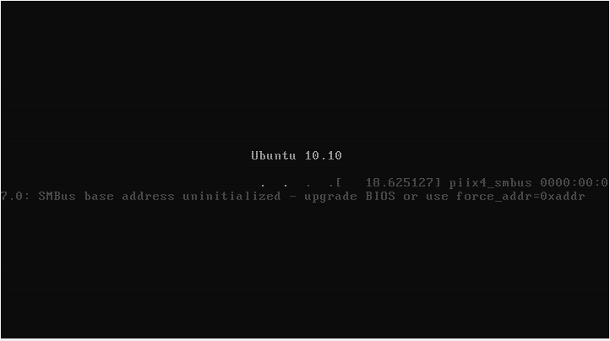Installation of Linux

Installation of Linux will start with this display.

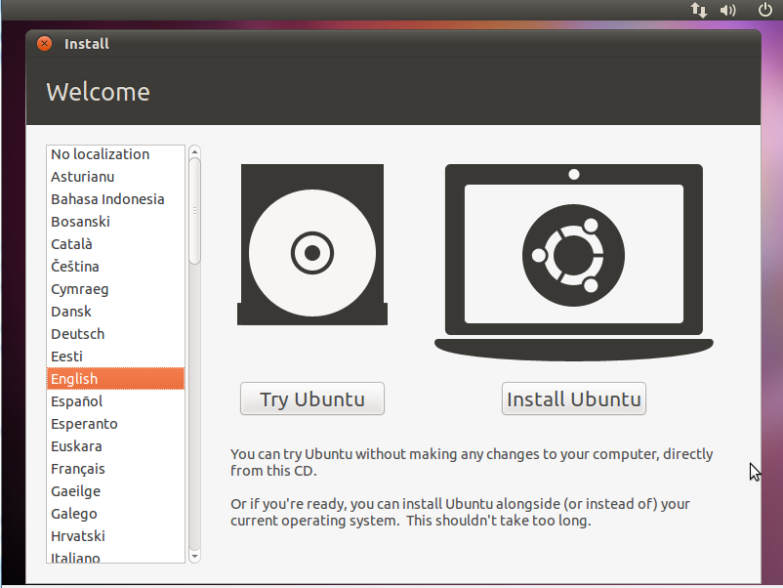

First thing you will do is to choose what language you will pick. Then click “Install Ubuntu”.

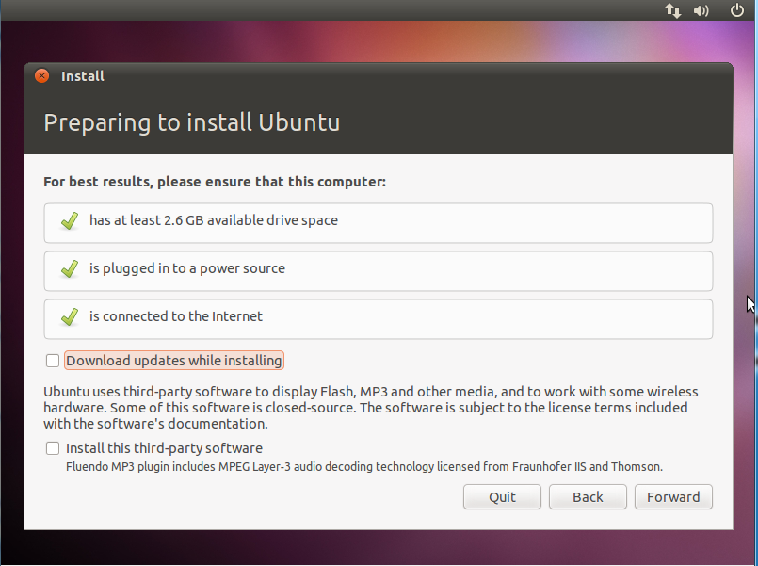

You are now preparing to install Ubuntu, just press “Forward”

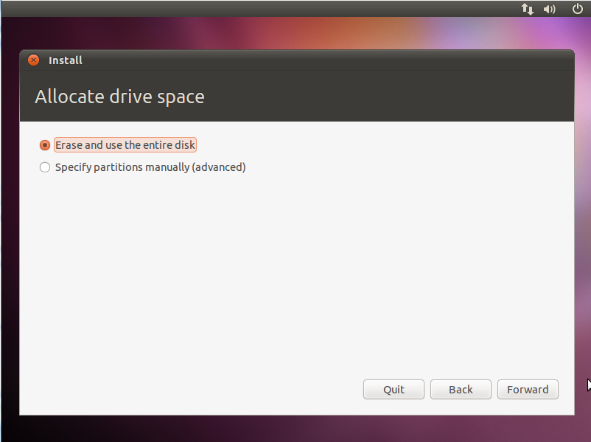

Allocate drive space will now appear, you will need to erase and use the entire disk to reformat then press “Forward”.

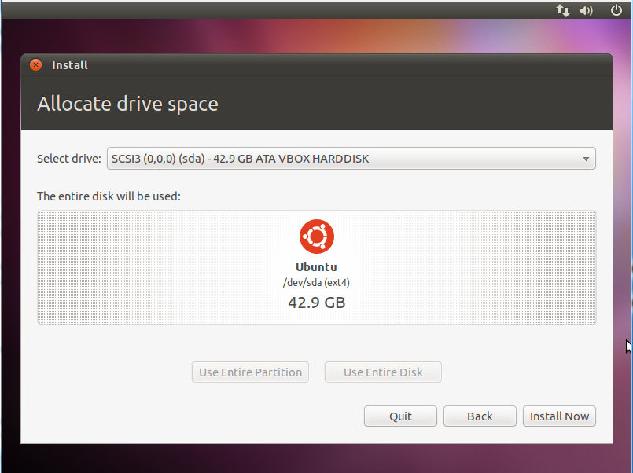

The entire disk will be use to install Linux in your operating system. Click “Install Now”.

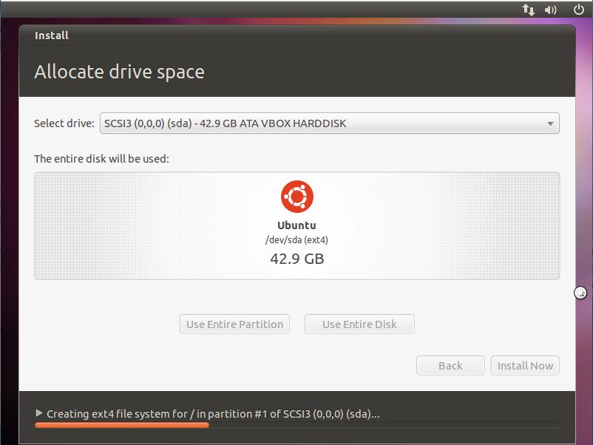

Installation process has now started. It will just take several minutes to install.

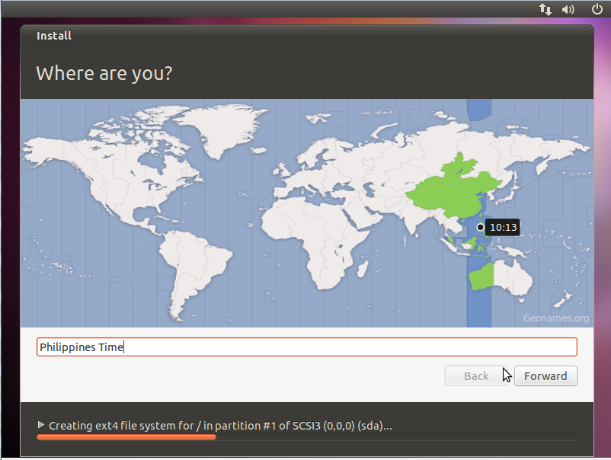

This display will show what GMT you are in right now.

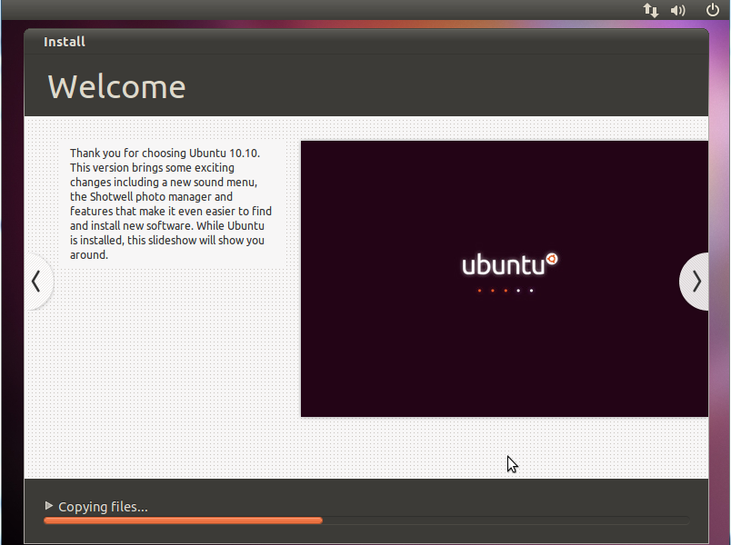

While Ubuntu 10.10 is installed, this slideshow will show you around.

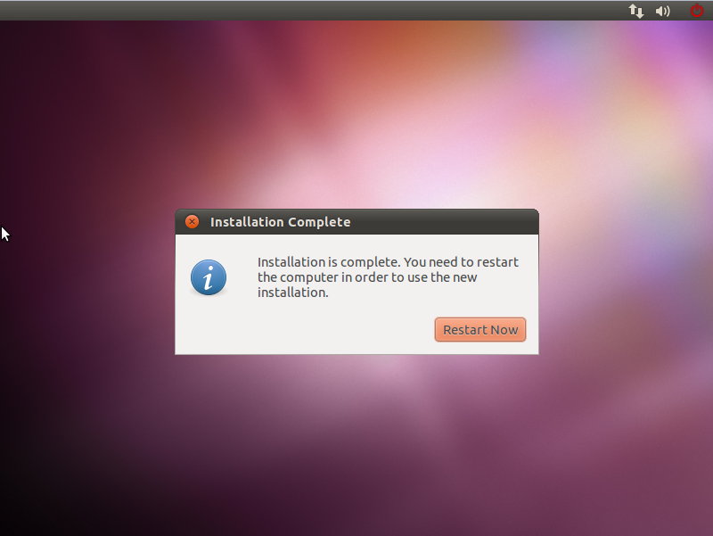

Installation of Ubuntu 10.10 is now complete. The computer will ask you to restart in

order to use the new operating system.

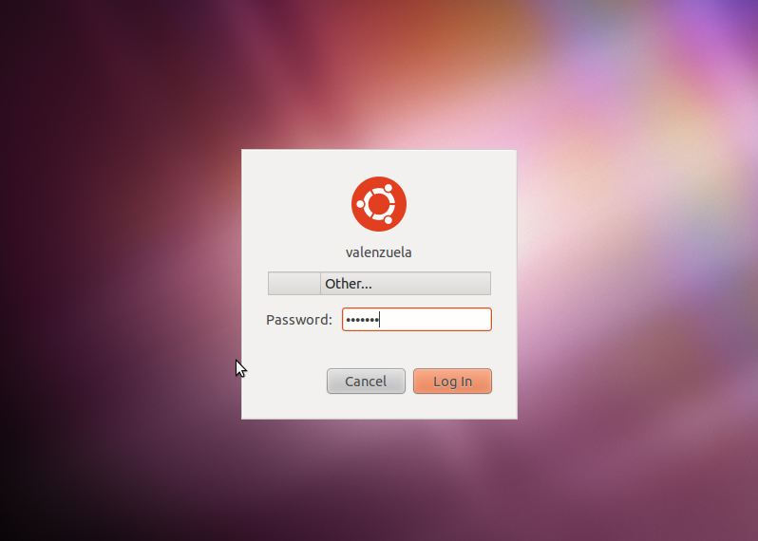

As you preferred to have a password, you will now enter your password to enter your desktop.

Adding User

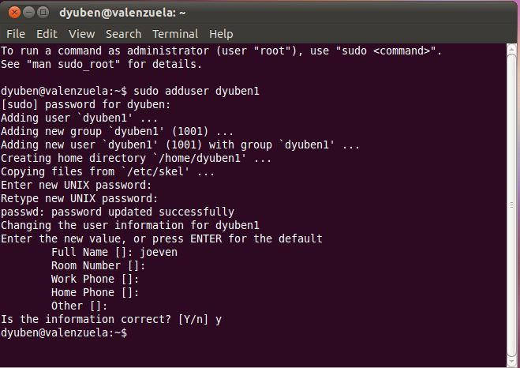

In order to add user, type in sudoadduser<desired username>. It will ask you

for password and some information. You can skip the information if you want to, then press Y

for yes. For the other employees’ usernames, they are listed below.

|  |  |
| --- | --- |
| Employees | Usernames |
| Jason Albores | sudoadduserjalbores |
| Ron Derek De Ramos | sudoadduserrdderamos |
| Kenneth Manansala | sudoadduserKenny |
| Joey Reyes | sudoadduserjreyes |
| Capt. Juan de la Cruz | sudoadduserjdlcruz |
| For supervisors | sudoadduser sprvsr1-5 |
| For other employees/members | sudoadduser emp1 – 13 |

Adding Group

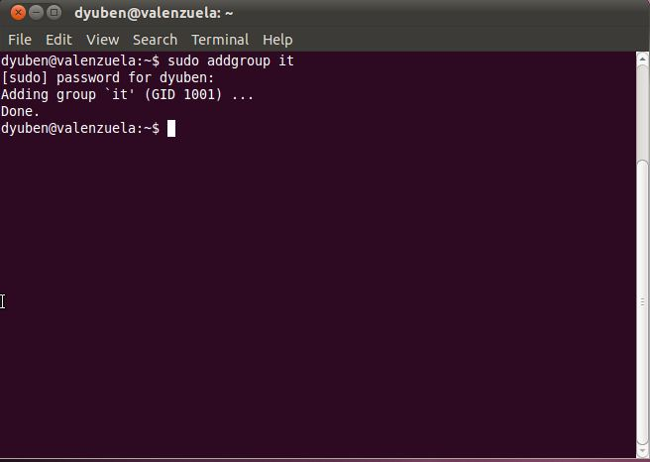

Same procedure for adding user ,sudoaddgroup<desired groupname>but it will not asks you for password or any information. Other groups are listed below.

|  |  |
| --- | --- |
| Departments | Group names |
| IT | sudoaddgroupitdept |
| Human Resource | sudoaddgrouphrdept |
| Marketing | sudoaddgroupmktgdept |
| Accounting | sudoaddgroupacctgdept |
| Customer Service | sudoaddgroupcsdept |
| Pilots, Flight Attendants and Crews | sudoaddgroupempdept |

Adding User to a Group

In order to create a user to a group, you must log in as the sudoer. After logging in, type the command “addgroup”. The syntax for this command is “sudoaddgroup<username><groupname>” then tap enter. Other admins and staffs were added in their respective groups. See below.

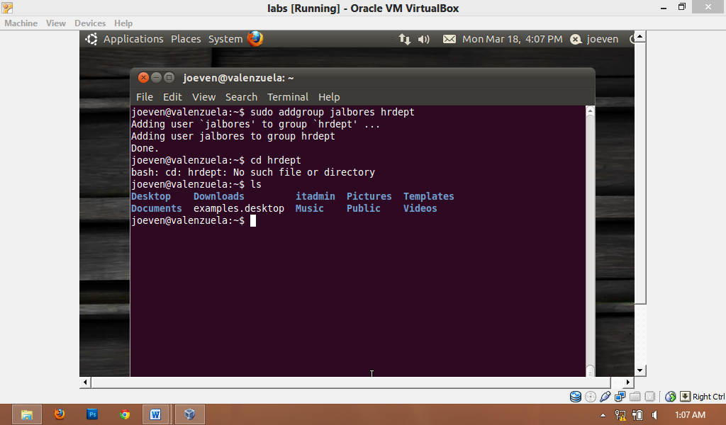

|  |  |
| --- | --- |
| Department Staffs | Command |
| Joeven Valenzuela | sudoaddgroupdyuben1 itdept |
| MaimaiMansanades | sudoaddgroupmaimaiitdept |
| Christine Reyes  Angel Locsin | sudoaddgroupcreyesitdept  sudoaddgroupalocsinitdept |
| Ron Derek De Ramos | sudoaddgrouprddramosmktgdept |
| Perigrine Rivera | sudoaddgrouppriveramktgdept |
| SolennHuesaff  Isabelle Daza | sudoaddgroupshuesaffmktgdept  sudoaddgroupidazamktgdept |
| Kenneth Manansala | sudoaddgroupkennyacctgdept |
| Kalvin James Manansala | sudoaddgroupkmanansalaacctgdept |
| Gerryl Sierra  John Michael Mendez | sudoaddgroupgsierraacctgdept  sudoaddgroupjmendezacctgdept |
| Joey Reyes | sudoaddgroupjreyescsdept |
| ChelaiManansala | sudoaddgroupcmanansalacsdept |
| Camille Rivera  Sarah Jean Valenzuela | sudoaddgroupcriveracsdept  sudoaddgroupsvalenzuelacsdept |
| Capt. Juan dela Cruz | sudoaddgroupjdlcruzempdept |
| Capt. Juan dela Cruz II  Capt. Juan dela Cruz III | sudoaddgroup jdlcruz2 empdept  sudoaddgroup jdlcruz3 empdept |
| Pauleen So  Akira Hassan  PalomaEsmeria | sudoaddgrouppsoempdept  sudoaddgroupahassanempdept  sudoaddgrouppesmeriaempdept |

Creating/Deleting Files and Directories

# Creating Files and Directories

For creating directories or folders, I use the command “mkdir”. The syntax for this command is “mkdir<directory name>”.For creating files, we use the command “touch”. The syntax for this command is “touch <file name>”.By using the command ls, we can able to see the files and directories we have created. Directories or folders are colored blue and files are colored white.

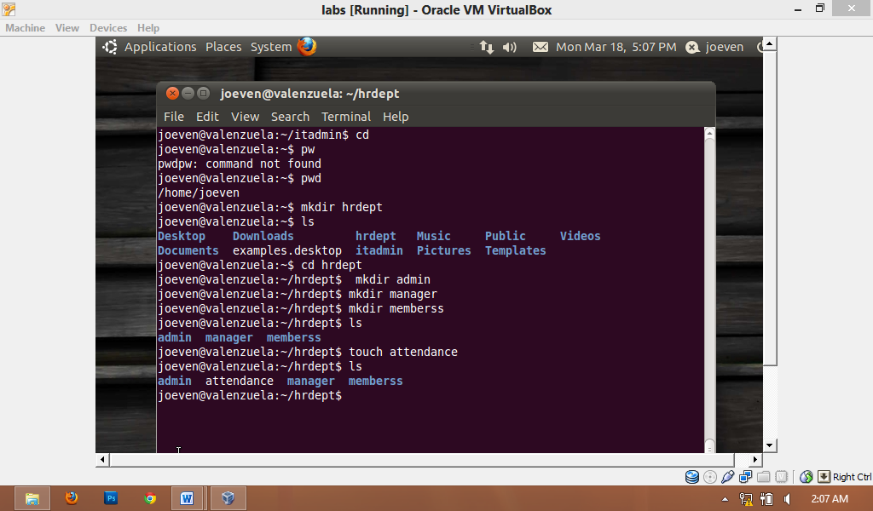

# Deleting Files and Directories

For deleting directories or folders, we use the command “rmdir”. The syntax for this command is “rmdir<directory name>”. For deleting files, we use the command “rm”. The syntax for this command is “rm<file name>”. You don’t need to be a sudoer to be able to delete files and directories.

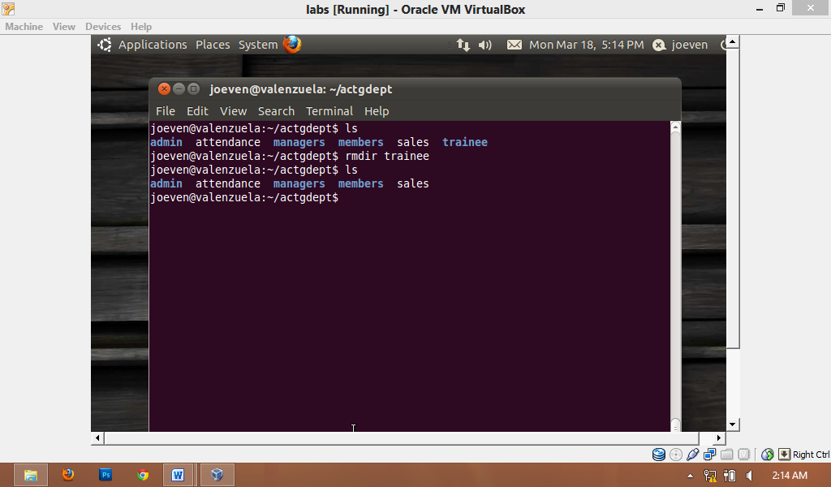

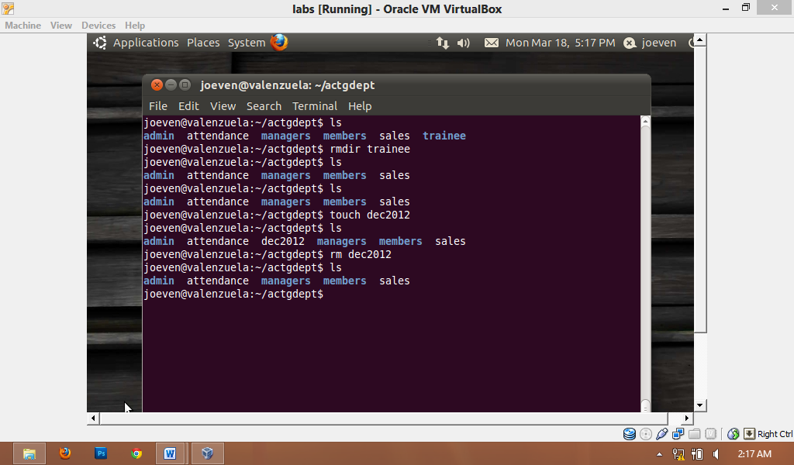

Common Linux Commands

|  |  |
| --- | --- |
| Command | Description |
| ls | Show all files and folders. |
| ls -al | Show all files and folders with its description. |
| pwd | Show the present working directory. |
| chmod | Changing the permission of a file or folder to its user, groups, and others. |
| touch | Creates a file. |
| mkdir | Makes a directory/folder. |
| rmdir | Removes a directory/folder. |
| groups | Shows your group. |
| rm | Removes a file. |
| cd | Go to $home directory |
| sudoaddgroup | Adding group to a user. |
| sudoadduser | Adding user. |
| sudo apt-get install | Install new programs. |
| sudo reboot | Restart OS. |
| sudo halt | Shutdown OS. |

Policy Settings

Policy settings are used to control the access among files or directories by the user (u), by its group (g) and by other users (o). Permissions are symbolized by “r” for read, “w” for write and “x” for executable.

**IT Folder “drwxr--r--”**

**itemp “drwxr--r--”**

Admin: Joeven Valenzuela “rwxrwxrwx”

MaimaiMansanades file “rwxr--r--“

Angel Locsin file “rwxr--r--“

Christine Reyes file “rwxr--r--“

**Human Resource Folder “drwxr**--**r**--**”**

**hremp “drwxr--r--”**

Admin: Jason Albores “rwxrwxrwx”

Isaiah San Jose file “rwxr--r--“

Danica Torres file “rwxr--r--“

Cyril Locsin file “rwxr--r--“

**Marketing Folder “drwxr--r--”**

**mktgemp “drwxr--r--”**

Admin: Ron Derek De Ramos “rwxrwxrwx”

Perigrine Rivera file “rwxr--r--“

SolennHuesaf file “rwxr--r--“

Isabelle Daza file “rwxr--r--“

**Accounting Folder “drwxr--r--”**

**acctgemp “drwxr--r--”**

Admin: Kenneth Manansala “rwxrwxrwx”

Kalvin James Manansalafile“rwxr--r--“

Gerryl Sierra file “rwxr--r--“

John Michael Mendez file “rwxr--r--“

**Customer Service Folder “drwxr--r--”**

**csemp “drwxr--r--”**

Admin: Manager: Joey Reyes “rwxrwxrwx”

ChelaiManansalafile “rwxr--r--“

Camille Rivera file “rwxr--r--“

Sarah Jean Valenzuela file “rwxr--r--“

**Pilots, Flight Attendants and Crews Folder “drwxr--r--”**

**pgcemp “drwxr--r--”**

Admin: Capt. Juan Dela Cruz “rwxrwxrwx“

Capt. Juan Dela Cruz II “rwx-r--r--“

Capt. Juan Dela Cruz III “rwxr--r--“

Paulene So “rwxr--r--“

Akira Hassan “rwxr--r--“

PalomaEsmeria “rwxr--r--“

# Change Mode/chmod

We used this Linux command to change permissions to the users, groups and for others. Here are some examples for changing modes.

|  |  |
| --- | --- |
| Policy Setting | Command |
| rwxr--r-- | sudochmod go-wx<file/directory name>  sudochmod 744 <file/directory name> |
| rwxrwxrwx | sudochmodugo+rwx<file/directory name>  sudochmod 777 <file/directory name> |
| r--rwxr-- | sudochmod u-wxg+rwx o-wx<file/directory name>  sudochmod 444 <file/directory name> |
| rw-rw-rw- | sudochmodugo-x <file/directory name>  sudochmod 666 <file/directory name> |
| r-xrwx-wx | sudochmod u-wxg+rwx o-r <file/directory name>  sudochmod 573 <file/directory name> |

Text Editor

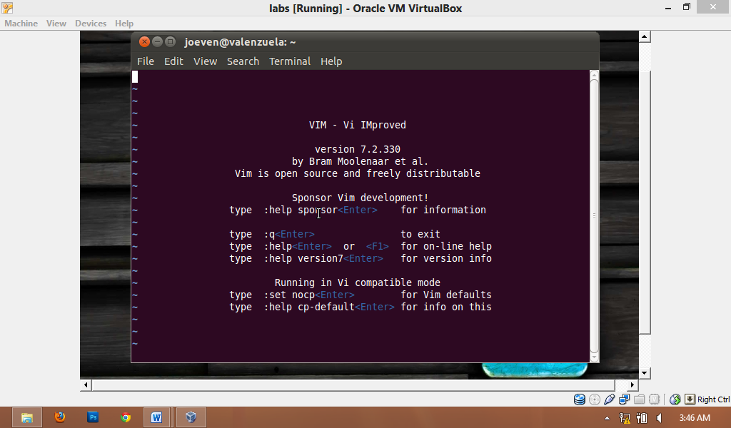

Vim stands for "ViIMproved". It used to be "Vi IMitation", but there are so many improvements that a name change was appropriate. Vim is a text editor which includes almost all the commands from the UNIX programs **vi**and a lot of new ones.

|  |  |
| --- | --- |
| Command | Description |
| vim/vi | Command line text editor. |
| Esc:wq! | Save and quit. |
| Esc:q! | Quit without saving. |
| less | To view the file. |
| I | To insert text. |

Web Browsers



A very popular open source Web browser for Windows, Mac and Linux from the Mozilla project. Including a search box for Google and other major sites, the Firefox user interface was designed to be easily customizable by adding "extensions," such as a stock tracker, autofill and hundreds of others.

X-Windows, Desktop Environment and Desktop Application/Tools

# GNOME.png

# GNOME

The GNOME Project was started in 1997 by two then university students, Miguel de Icaza and Federico Mena. Their aim: to produce a free (as in freedom) desktop environment. Since then, GNOME has grown into a hugely successful enterprise. Used by millions of people across the world, it is the most popular desktop environment for GNU/Linux and UNIX-type operating systems. The desktop has been utilised in successful, large-scale enterprise and public deployments, and the project's developer technologies are utilised in a large number of popular mobile devices.

GNOME is much more than just a desktop environment for Linux. It has emerged as a standard around which many traditional UNIX vendors have begun to coalesce and has become a shining example of how the open source community can work together with commercial vendors.

# Open Office



OpenOffice is developed for [Linux](http://en.wikipedia.org/wiki/Linux), [OS X](http://en.wikipedia.org/wiki/OS_X) and [Windows](http://en.wikipedia.org/wiki/Microsoft_Windows), with ports to other [operating systems](http://en.wikipedia.org/wiki/Operating_system). It is distributed under the [Apache License](http://en.wikipedia.org/wiki/Apache_License).OpenOffice contains a [word processor](http://en.wikipedia.org/wiki/Word_processor) ([Writer](http://en.wikipedia.org/wiki/OpenOffice_Writer)), a [spreadsheet](http://en.wikipedia.org/wiki/Spreadsheet) ([Calc](http://en.wikipedia.org/wiki/OpenOffice_Calc" \o "OpenOffice Calc)), a [presentation](http://en.wikipedia.org/wiki/Presentation_program) application ([Impress](http://en.wikipedia.org/wiki/OpenOffice_Impress)), a [drawing](http://en.wikipedia.org/wiki/Graphics_software) application ([Draw](http://en.wikipedia.org/wiki/OpenOffice_Draw)), a [formula editor](http://en.wikipedia.org/wiki/Formula) ([Math](http://en.wikipedia.org/wiki/OpenOffice_Math)), and a [database management](http://en.wikipedia.org/wiki/Relational_database_management_system) application ([Base](http://en.wikipedia.org/wiki/OpenOffice_Base)).

Troubleshooting Linux

### Case Sensitive

Linux commands are case sensitive. Be sure to check your spelling before hitting the enter key.

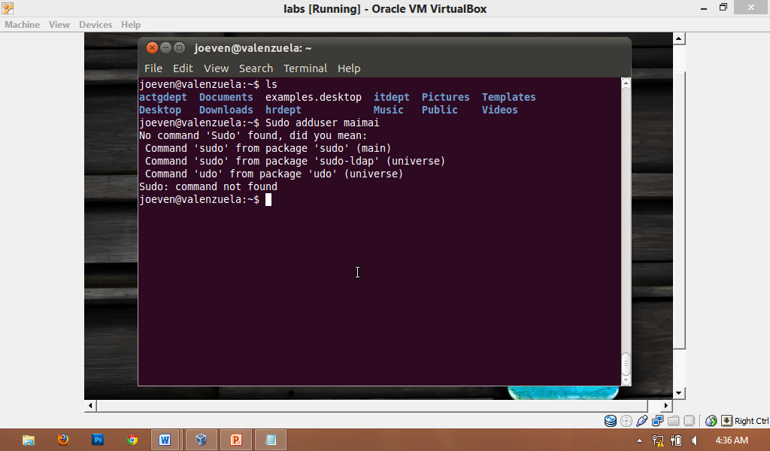

### No such file or directory

It means you don’t have any file with that name or it is located in another folder. You can use the command **ls** for checking your directory.

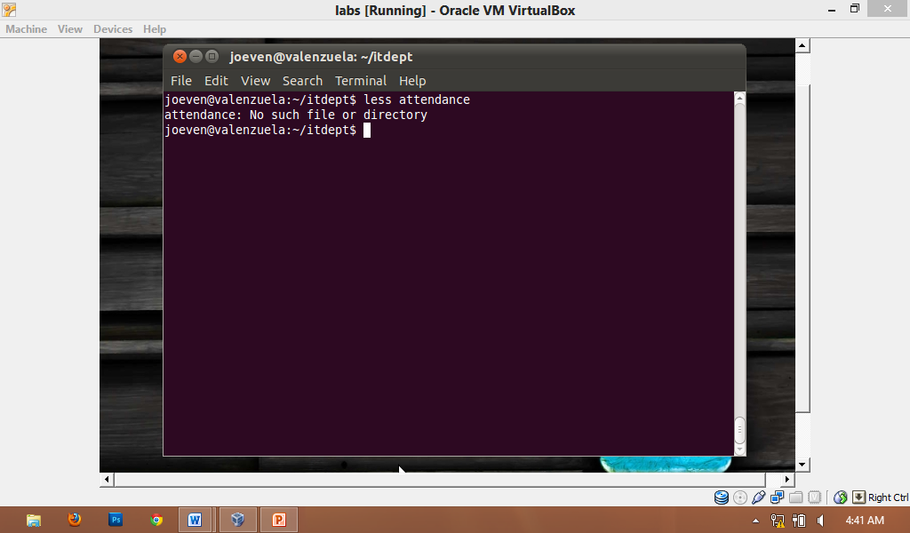

### Unknown Linux command

Be sure to type a correct Linux command.

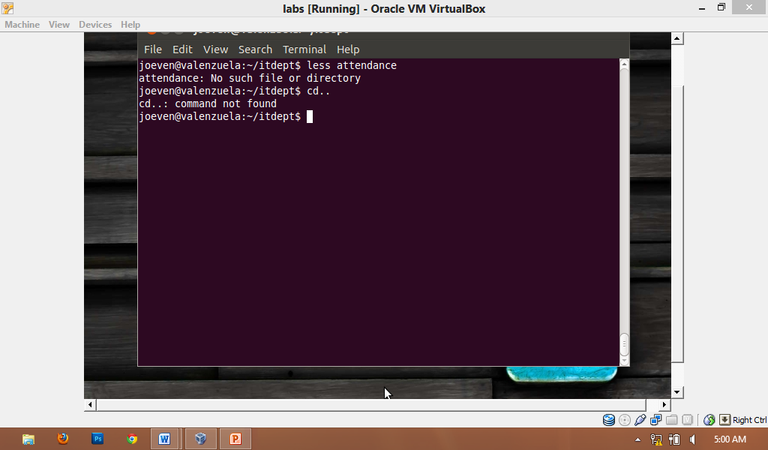

Shell Script

#!/bin/bash

echo "=================== "

echo "= Singapura Air =”

echo "================== "

echo "Menu "

choice=7

echo "[1] IT Department"

echo "[2] Human Resource Department"

echo "[3] Accounting Department"

echo "[4] Marketing Department"

echo “[5] Customer Service Department”

echo “[6] Pilots and Other Employees”

echo "Department: "

while [ $choice -eq 7 ];

do read choice

if [ $choice -eq 1 ]; then

echo "==================="

echo “= IT DEPARTMENT =”

echo “===================”

echo "Name:"

read name

echo "Contact No: "

read con

echo “Address:”

read addr

echo “Age:”

read age

echo “Working Hours:”

read work

let multiply=600*$work

echo "Gross Salary: " $multiply

echo "SSS: 200"

echo "Philhealth: 50"

echo "Pagibig: 90"

echo "Tax: 500"

let addd=200+50+90+500

echo "Total Deduction: " $addd

let add=$multiply+$addd

echo "Net Salary: " $add

else if [ $choice -eq 2 ]; then

echo "==================="

echo “= HR DEPARTMENT =”

echo “===================”

echo "Name:"

read name

echo "Contact No: "

read con

echo “Address:”

read addr

echo “Age:”

read age

echo “Working Hours:”

read work

let multiply=600*$work

echo "Gross Salary: " $multiply

echo "SSS: 200"

echo "Philhealth: 50"

echo "Pagibig: 90"

echo "Tax: 500"

letaddd=200+50+90+500

echo "Total Deduction: " $addd

let add=$multiply+$addd

echo "Net Salary: " $add

else if [ $choice -eq 3 ]; then

echo "======================="

echo “= ACCTG DEPARTMENT =”

echo “=======================”

echo "Name:"

read name

echo "Contact No: "

read con

echo “Address:”

read addr

echo “Age:”

read age

echo “Working Hours:”

read work

let multiply=600*$work

echo "Gross Salary: " $multiply

echo "SSS: 200"

echo "Philhealth: 50"

echo "Pagibig: 90"

echo "Tax: 500"

letaddd=200+50+90+500

echo "Total Deduction: " $addd

let add=$multiply+$addd

echo "Net Salary: " $add

else if [ $choice -eq 4 ]; then

echo "======================="

echo “= MKTG DEPARTMENT =”

echo “=======================”

echo "Name:"

read name

echo "Contact No: "

read con

echo “Address:”

read addr

echo “Age:”

read age

echo “Working Hours:”

read work

let multiply=600*$work

echo "Gross Salary: " $multiply

echo "SSS: 200"

echo "Philhealth: 50"

echo "Pagibig: 90"

echo "Tax: 500"

letaddd=200+50+90+500

echo "Total Deduction: " $addd

let add=$multiply+$addd

echo "Net Salary: " $add

else if [ $choice -eq 5 ] then

echo "======================="

echo “= CS DEPARTMENT =”

echo “=======================”

echo "Name:"

read name

echo "Contact No: "

read con

echo “Address:”

read addr

echo “Age:”

read age

echo “Working Hours:”

read work

let multiply=600*$work

echo "Gross Salary: " $multiply

echo "SSS: 200"

echo "Philhealth: 50"

echo "Pagibig: 90"

echo "Tax: 500"

letaddd=200+50+90+500

echo "Total Deduction: " $addd

let add=$multiply+$addd

echo "Net Salary: " $add

else if [ $choice -eq 6 ]; then

echo "================================"

echo “= PILOT AND OTHER EMPLOYEES =”

echo “================================”

echo "Name:"

read name

echo "Contact No: "

read con

echo “Address:”

read addr

echo “Age:”

read age

echo “Working Hours:”

read work

let multiply=600*$work

echo "Gross Salary: " $multiply

echo "SSS: 200"

echo "Philhealth: 50"

echo "Pagibig: 90"

echo "Tax: 500"

letaddd=200+50+90+500

echo "Total Deduction: " $addd

let add=$multiply+$addd

echo "Net Salary: " $add

else choice=7

fi

fi

fi

fi

fi

fi

fi

done

References

<http://www.linux-mag.com/id/668/>

http://en.wikipedia.org/wiki/OpenOffice